- Project Overview
Project Title: Ecclesia
Description:
The app provides users with information about dioceses, vicariates, and churches in the Philippines. It shows church history, mass schedules, and confession schedules. The app is offline-first, allowing access to data even without internet. Optional features include GPS nearest church functionality and map visualization.
Objectives:
- Provide offline access to church information
- Simplify navigation through Diocese → Vicariate → Church
- Improve access to mass and confession schedules
- Project Scope
In-Scope (Model – View – Presenter):
- Diocese → Vicariate → Church Navigation
- Church Details: History, Mass Hours, Confession Hours
- Offline Storage using SQLite
Out-of-Scope (Full Enhancements):
- Daily / Weekly Prayers Download
- Notifications for Feast Days or Mass Times
- Map view with offline caching
- Admin panel for data management
- Tools and Technology used
Component | Technology | Purpose
Mobile Application | Flutter + Dart | Cross-platform Development
Database | SQLite (sqflite) | Offline Storage
Global Positioning System | Geolocator | Optional nearest church feature
Map | Google Maps Flutter | Optional Visualization
Networking | http, connectivity_plus | Future updates
Background Tasks | Workmanager | Optional sync for prayers

- System Architecture and Flow
Offline-first Design:
Flutter App
├── SQLite Database
├── GPS / Geolocator (optional)
└── Optional Backend API (Spring Boot for updates)
Application Flow:
- Load SQLite preloaded data
- Navigate Diocese → Vicariate → Church
- View Church Details (History, Mass, Confession)
- Optional: Find nearest church with GPS

- Database Schema
  - Tables and Description
    - Diocese Table
Column | Data Type | Constraints | Description
id | INTEGER | PRIMARY_KEY, AUTOINCREMENT | Unique identifier for each Diocese
name | TEXT | NOT NULL, UNIQUE | Name of the Diocese
region | TEXT | NOT NULL | Geographical region or administrative area
description | TEXT | NULLABLE | Brief historical or descriptive information about the diocese
Purpose: Stores all Dioceses in the system. Each Diocese can have multiple vicariates.
    - Vicariate Table
Column | Data Type | Constraints | Description
id | INTEGER | PRIMARY_KEY, AUTOINCREMENT | Unique identifier for each Vicariate
diocese_id | INTEGER | FOREIGN KEY REFERENCES Diocese (id) ON DELETE CASCADE | Links vicariate to its parent diocese. Deleting a diocese deletes all associated vicariates.
name | TEXT | NOT NULL | Name of the Vicariate
Purpose: Represents subdivisions within a diocese. A vicariate can have multiple churches.
    - Church Table
Column | Data Type | Constraints | Description
id | INTEGER | PRIMARY_KEY, AUTOINCREMENT | Unique identifier for each Church
vicariate_id | INTEGER | FOREIGN KEY REFERENCES Vicariate (id) ON DELETE CASCADE | Ensures church belongs to a vicariate; deleting a vicariate deletes associated churches
name | TEXT | NOT NULL | Name of the Church
address | TEXT | NOT NULL | Full address of the Church
latitude | REAL | NULLABLE | Geographical latitude (for GPS features)
longtitude | REAL | NULLABLE | Geographical longtitude (for GPS features)

Purpose: Stores detailed information about individual churches, including location, history, and administrative linkage.
    - Mass Schedule Table
Column | Data Type | Constraints | Description
id | INTEGER | PRIMARY_KEY, AUTOINCREMENT | Unique identifier for each Diocese
church_id | INTEGER | FOREIGN KEY REFERENCES Church (id) ON DELETE CASCADE | Ensures schedule is linked to a church; deleting a church deletes schedules
day | TEXT | NOT NULL | Day of the Week (e.g., Monday, Sunday)
time | TEXT | NOT NULL | Time of the mass
language | TEXT | NULLABLE | Language of the mass (optional)

Purpose: Stores the mass schedules for each church to allow offline access and display.
    - Confession Schedule Table
Column | Data Type | Constraints | Description
id | INTEGER | PRIMARY_KEY, AUTOINCREMENT | Unique identifier for each Diocese
church_id | INTEGER | FOREIGN KEY REFERENCES Church (id) | Links schedule to a specific church
day | TEXT | NOT NULL | Day of the Week for confession
time | TEXT | NOT NULL | Time of the confession

Purpose: Stores confession schedules for churches, allowing users to check available times offline.
  - Key Relationships (ER Diagram)
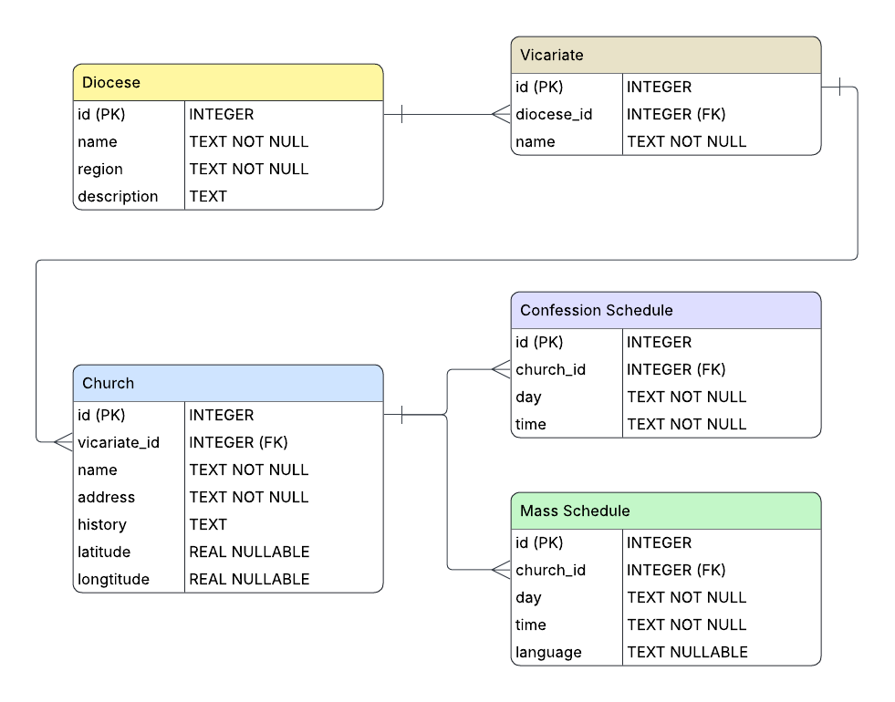

- Flutter App Structure
  - Directory Structure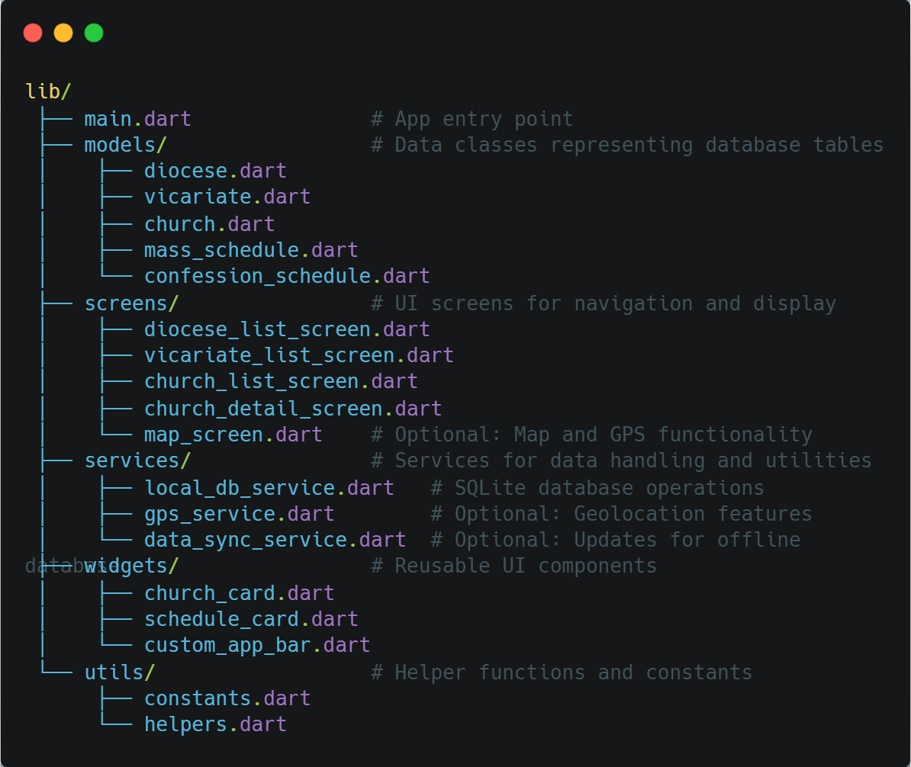

  - Models
The models represent the database tables and map data from SQLite to Dart Objects
Model | Description
Diocese | Represents a diocese with attributes: id, name, region, description
Vicariate | Represents a vicariate linked to a diocese
Church | Represents a church linked to a vicariate; includes address, history, latitude, longitude
MassSchedule | Represents a mass schedule for a church, including day, time, and language
ConfessionSchedule | Represents a confession schedule for a church, including day and time

  - Screens
Each screen represents a UI page or section in the app.
Screen | Description
DioceseListScreen | Displays all dioceses; allows navigation to vicariates
VicariateListScreen | Displays all vicariates under a selected diocese
ChurchListScreen | Displays all churches under a selected vicariate
ChurchDetailScreen | Shows church details including history, mass, and confession schedules
MapScreen (Optional) | Shows church locations on a map with GPS integration

  - Services
Services manage data operations and business logic separate from UI.
Service | Description
LocalDbService | Handles SQLite operations: insert, query, update, delete
GpsService (Optional) | Provides nearest church calculation using device GPS
DataSyncService (Optional) | Updates local database from online JSON or API

  - Sample Code Snippets
- UI/UX Design
  - Screen Flow
  - Wireframes
- Agile / Scrum Development Plan
  - Roles
  - Backlog & User Stories
  - Sprint Planning
- Development & Maintenance
- References

